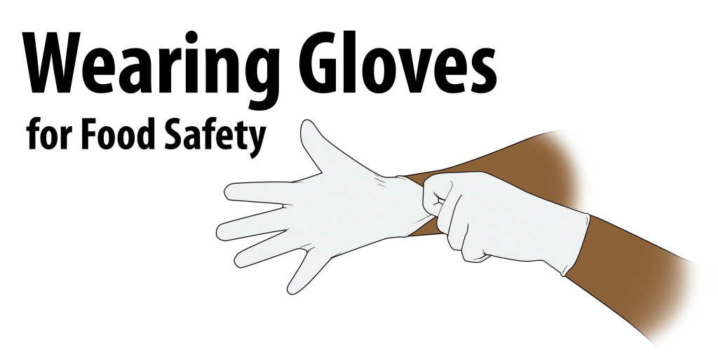

1. Always wash your hands before putting on gloves.
2. Wear gloves to help prevent contaminating ready to eat foods.
3. Or to protect a food contact surface such as opening a milk carton for a child.
4. Change you gloves anytime you should need to wash your hands. Especially:
- After touching your body or hair
    - After using the toilet
    - After eating or drinking
    - After handling dirty utensils or equipment
    - After handling raw food
    - After any activity that contaminates your gloves
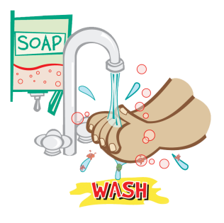
5. Remember to wash your hands before changing gloves.

Gloves Work-----ONLY When You Wear Them Correctly!

